Overview:

The nonprofit foundation Alphabet Soup wants a tool that can help it select the applicants for funding with the best chance of success in their ventures. A binary classifier that can predict whether applicants will be successful if funded by Alphabet Soup could help them select applicants for funding.

Preprocessing:

Neural Network was used on each model and originally set with 2. For the final model, 3 layers

were added that helped achieve an accuracy of over 75%.

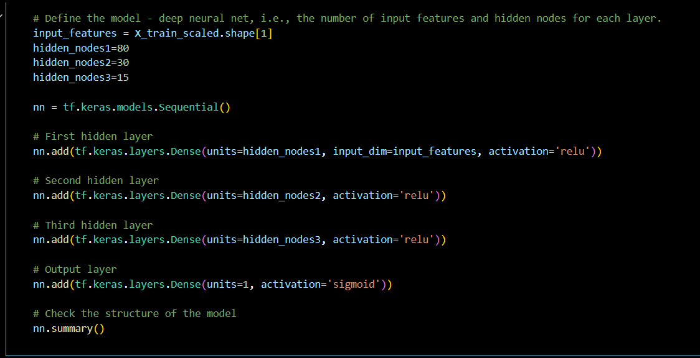

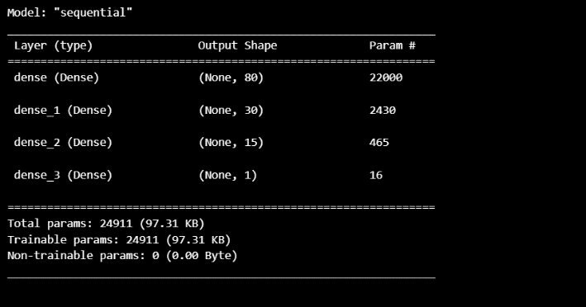

Also, I kept Name in the model and applied Name as a feature and binned the values. I kept classification as a feature in the model as well.

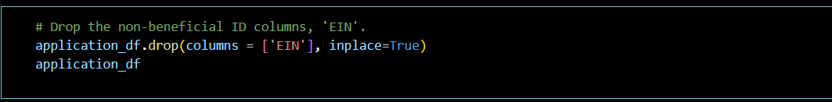

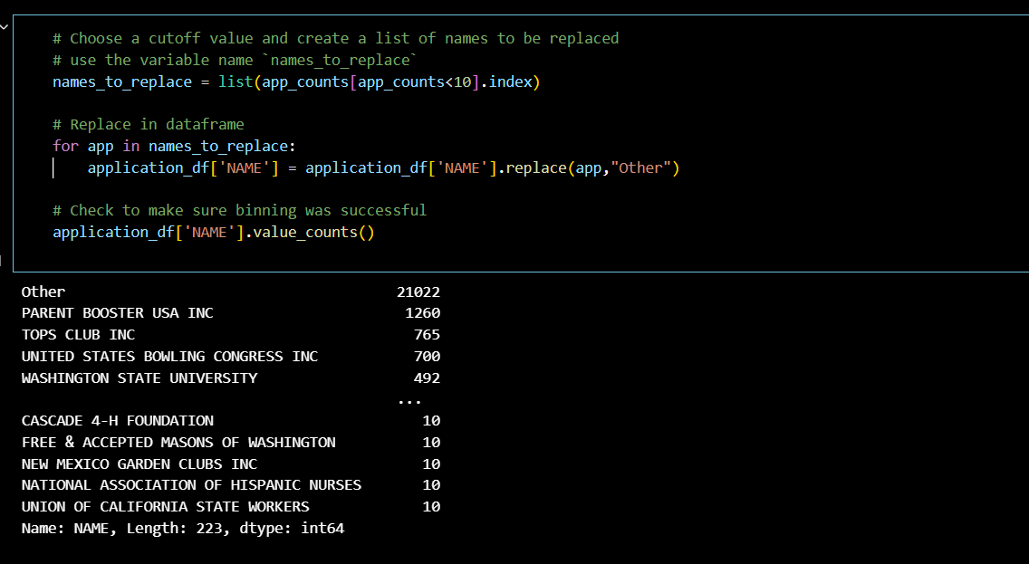

In addition to the changes previously mentioned, I also added a third layer and changed the

epochs to 200 instead of 100.

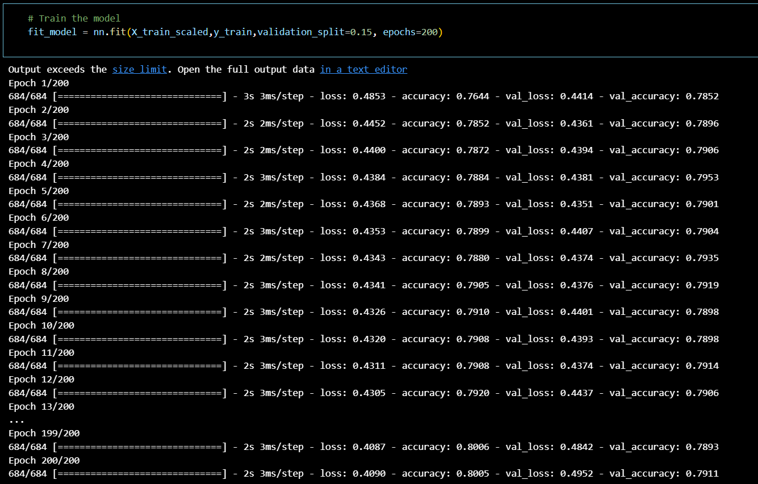

Summary:

Several layers should be considered, so that it can continue to predict and classify information

based on the model.

